LI-ION TAMER RACK MONITOR
ENGINEERING SPECIFICATIONS

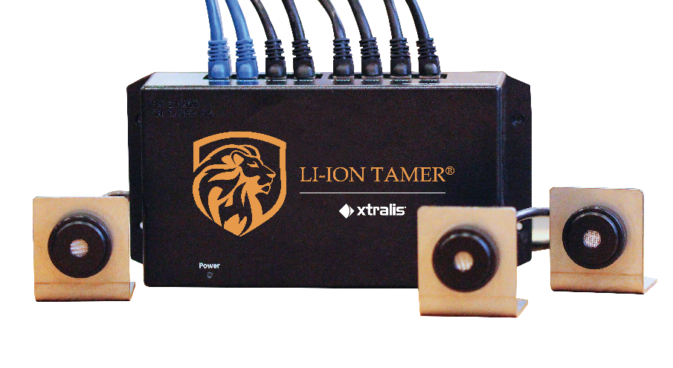

OFF-GAS DETECTION SYSTEM FOR LITHIUM-ION BATTERIES

August 2020
Doc. No. 35905_01

Contents
1 General 1
2 Components 2
2.1 Sensors: Monitoring Sensor (Part # LT-SEN-M) & Reference Sensor (Part # LT-SEN-R) 2
2.2 Controller: Combined Controller (Part # LT-CTR-C) 2
2.3 Cables: Sensor Cable, Power Cable, Communication Cable, Daisy Chain Cable 3
2.4 Adapters: MODBUS adapter, Relay 3
3 Execution 4
3.1 Installation 4
3.2 Maintenance 4

General
The off-gas monitoring system is a system comprised of a distributed sensing network that is designed to monitor lithium-ion batteries off gassing. The off-gas detection system should be installed in accordance with the manufacturer’s recommendations.
The system includes the following components:
- Sensor
- Controller
- Cable
- Adapter (optional)

Components

Sensors: Monitoring Sensor (Part # LT-SEN-M) & Reference Sensor (Part # LT-SEN-R)
- Monitoring Sensors should be distributed in the application to monitor for lithium-ion battery cell venting.
- Reference Sensors should be distributed in the application to monitor air contaminants.
- Sensors will have power supply rated at 3 – 16 VDC.
- Sensors can communicate status of error, warm-up, normal, and alarm.
- Sensor can operate within relative humidity ranges 5 – 95% and temperature ranges of 14°F to 140°F (-10°C to 60°C). The maximum allowable temperature change is 8.6°C/min.
- The unit will be certified to UL/IEC 61010 for product safety, EN60326-1 for EU Directive (2014/30/EU), RoHS 3 EU 2015/863 and REACH compliant.
- The sensor and controller must be manufactured in an ISO 9001:2015 production environment.
- The sensor shall be capable of self-diagnosing error states.
- The sensor should be checked with yearly maintenance checks to continue sensor performance. The validation of sensor operation shall be done in accordance with the manufacturer’s recommendations.

Controller: Combined Controller (Part # LT-CTR-C)
- The Controller distributes power to the sensors, aggregates and processes sensor signals, and provides communication of sensor status.
- The Controller aggregates 12 Monitoring Sensors and 3 Reference Sensors.
- Multiple Controllers can be used when Controllers are properly daisy chained together by cables.
- The Controller processes the sensor signal status and communicates if a lithium-ion battery cell venting has occurred.
- The Controller will require a power supply rated at 12 – 28 VDC.
- The Controller has a power consumption detailed in the table below:
Table 1: Power Consumption
Detail | Specification
Controller (no sensors) | 2.4 W (at 24 Vdc)
 | 1.4 W (at 12 Vdc)
Sensor | 275 mW (at 5 Vdc)
Controller (fully populated, 15 sensors) | 6.6 W (at 24 Vdc)
 | 5.6 W (at 12 Vdc)

- The Controller will be protected by a 3.5 A replaceable fuse.
- The Controller will communicate individual and aggregated sensor status’ through two digital output ports and/or MODBUS RTU over RS-232.
- The Controller will communicate aggregated sensor error status’ through digital output and MODBUS RTU over RS-232.
- The Controller will communicate aggregated sensor network (sensors on all Controllers that are daisy chained) status’ through digital output and MODBUS RTU over RS-232.
- The Controller will communicate individual sensor error and alarm status locally through LED indicators.

Cables: Sensor Cable, Power Cable, Communication Cable, Daisy Chain Cable
- Monitoring Sensor Cables are black 8P8C RJ45 shielded 24-28 AWG cable.
- Reference Sensor Cables are blue 8P8C RJ45 shielded 24-28 AWG cable.
- Daisy Chain Cables are grey 8P8C RJ45 shielded 24-28 AWG cable.
- Power Cables are 3-pin Molex connectors that include earth ground and terminate in bare wire leads.
- Digital Output Cables are 10-pin Molex connectors that terminate in bare wire leads.
- Serial Cables are female-to-female RS-232 cables.

Adapters: MODBUS adapter, Relay
- The MODBUS TCP/IP adapter has the ability to convert the Controller’s native MODBUS RTU communication protocol to MODBUS TCP/IP.
- The Relay will turn the digital output signal into a dry contact signal.

Execution

Installation
The installation should be done in accordance with the manufacturer’s recommendations.

Maintenance
The maintenance procedure should be done in accordance with the manufacturer’s recommendations.

